
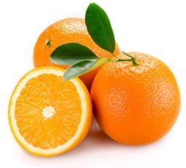
- 2.
……………… ………………

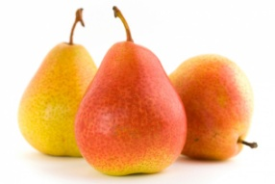
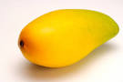
3. ………………. 4. ………………

5. ……………… 6. 6. ………………

7. ……………… 8. ………………

9. ……………… 10. ………………

11. ……………… 12. ………………

13. ……………… 14. ………………

15. ……………… 16. ………………

17. ……………… 18. ………………

19. ……………… 20. ………………




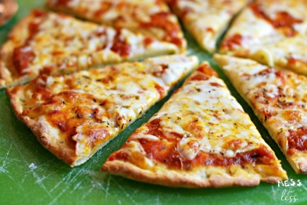
-

21. 22.

Choose and write

What Where’s What When

1/……………….. her doll? Her doll is in the living room.

2/ .………………. does he like? She likes cards.

3/……………….. do you have English? On Monday.

4/……………….. time is it? It’s five o’clock.

Question 2: Read and answer the questions:
Yes, he does. No, he doesn’t. Yes, he does. No,he doesn’t.
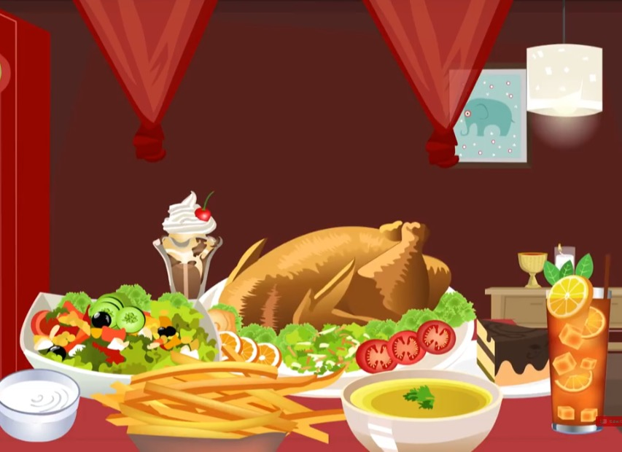
1/ Does he have a pizza?

……………………………………

2/ Does he have noodles?

……………………………………

3/ Does he have chicken?

……………………………………

4/ Does he have salad?

…………………………………
II/ Look and answer the questions( 4 pts)

1/ What time does she have break fast? 2/ What do you do in the afternoon?
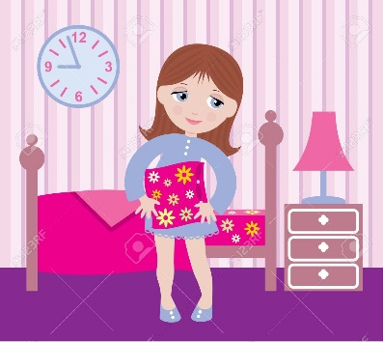
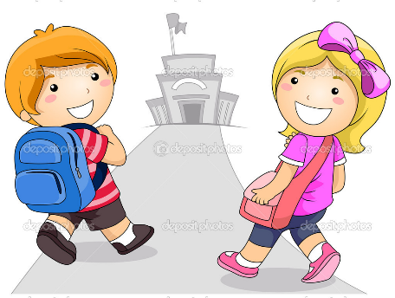

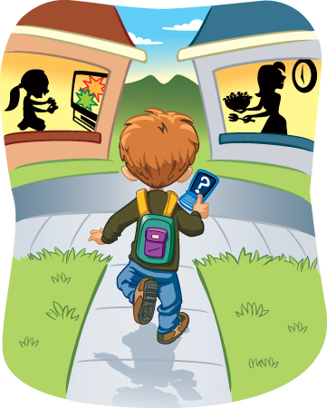

3/ What do they do in the morning? 4/ What time do you go to bed?

3.
Monday | Tuesday | Wednesday | Thursday | Friday
English | Vietnamese | P.E | Music | Art

1. What do you have on Tuesday? - I have ……………………………….
2. What……..………………… Wednesday? I have ………………………
3. ……………………………………………? ………………………Art
4. ……………………………….Monday? ……………………………..
4. Read and guess. What is it? Circle A, B or C
(A)
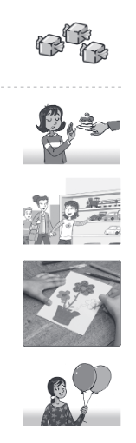
Example I like candy.
(B) There are three baloons.
(C) Let’s buy a card.
1. (A) She doesn’t like presents.
1
(B) She doesn’t like candy.
(C) She doesn’t like cake.
2. (A) Let’s go see our neighbor.
2
(B) Let’s buy a present for Billy.
(C) Let’s have some candy for Rosy.
3. (A) Let’s buy a present for Nga.
3
(B) It’s mom’s birthday. Let’s make a card.
(C) It’s my birthday cake.
4. (A) Here are the balloons.
4
Does Louise like balloons?
(B) It’s Lousie’s birhday on Monday.
Does she like candy?
(C) I like these balls. Let’s buy some for
Louise. It’s her birthday!

5. Look at the picture and the sentences, write True or False.

Welcome to my classroom! This is class 3/4. There are twenty boys and twenty five girls in my class. This is me, Chi.That is our teacher, Ms.Lan. There is an ABC poster on the wall and a big board. There are four big windows, one door and many computers. I hope you like Class 3/4’s classroom. I love it.
Example: 0. Her teacher is Ms Lan. T
1. There are forty-five students in Chi’s class. ___
2. There is not a poster and a board. ___
3. Chi doesn’t like the classroom. ___
6. Look at the pictures. Read and match :

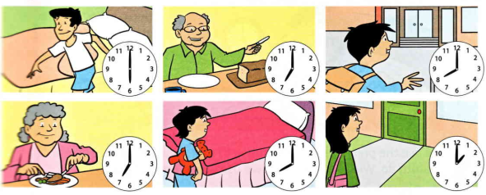

- Dad gets up at  - Grandpa has breakfast at  - The boy goes to school at | - Seven o’clock.  - Eight o’clock.  - Six o’clock.

